# 

Woburn Lower School

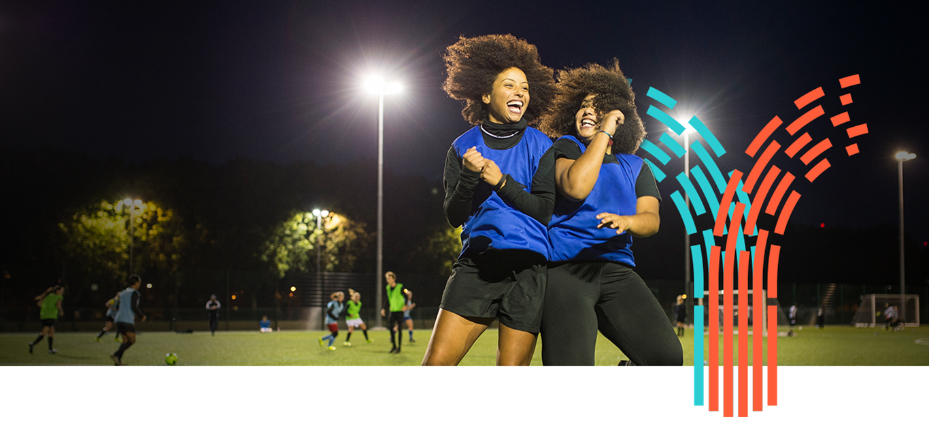

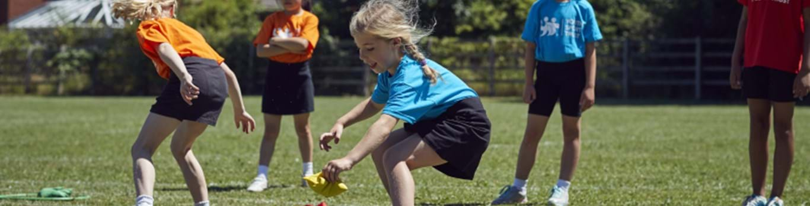

*Evidencing the impact of the Primary PE and Sport Premium*

*July 2022*

Support for review and reflection - considering the 5 key indicators from DfE, what development needs are a priority for your setting and your pupils now and why? Use the space below to reflect on previous spend and key achievements and areas for development.

|  |  |
| --- | --- |
| Key achievements to date until July 2022: | Areas for further improvement and baseline evidence of need: |
| Increased provision of high quality PE lessons through support from Leighton Linslade School Sports Partnership (LLSSP) specialist staff.  Increased pupil participation in range of extra –curricular opportunities,  Support targeted children to develop a healthy, active lifestyle through the provision of an Energize club led by qualified coaches from LLSSP  Increased the opportunity for children to be engaged in leadership through specific training for Sports Leadership from LLSSP including running Level 0 and Level 1(Intra) School Games events.  Increased the level of participation in inter-school competitions, supporting opportunities for all children and becoming fully inclusive.  Support all Year 4 children develop life skills, through Level 1 Bikeability Training  Support opportunities to raise standards across all areas of PE and School Sport  Students have been given the opportunity to train as Sports Leader |  |

|  |  |  |  |  |
| --- | --- | --- | --- | --- |
| **Academic Year:** 2021/22 | **Total fund allocated:** £ | **Date Updated:** | |  |
| **Indicator 1: The engagement of all pupils in regular physical activity – the Chief Medical Officer guidelines recommend that all children and young people aged 5 to 18 engage in at least 60 minutes of physical activity a day, of which 30 minutes should be in school** | | | | Percentage of total allocation: |
| % |
| **Intent** | **Implementation** | | **Impact** |  |
| School focus with clarity on intended impact on pupils: | Actions to achieve: | Funding allocated: | Evidence of impact: | Sustainability and suggested next steps: |
| To support all children to develop a healthy and active lifestyle | | Analysis of activity levels of pupils and targeted programme of intervention | LLSSP Membership | Identified pupils having access to club  Increase self-confidence and fitness levels for those that attended | Yearly Programme |
| Offering all Year 4 Pupils Bikeability training (Level 1) | | Use LLSSP Links to provide training in this essential life skill | LLSSP Membership | By the time pupils will have been offered training in this skill | Yearly Programme |
| Offer all girls the opportunity to engage in the Girls Active programme | | Targeted intervention programme designed to address the national imbalance of activity levels between boys and girls, using the Girls FA and Disney Active Play through storytelling resources | LLSSP Membership | Children develop skills that illustrate progression throughout the year groups and key stages | Yearly Programme |
| School Games Sport Specific training programme/coaching | | Upskilling pupils and staff within a series of School Games events – preparing the teams for School Games Level 2 Experience | LLSSP Membership | Children develop skills that illustrate progression throughout the year groups and key stages | Yearly Programme |
| Young Leaders (Events) are being developed | | Use LSSP links to provide Level 1 School Games event management training and support. | LLSSP Membership | Children take a lead role in the planning and delivery of Intra School events for their peers or younger year groups.  They develop organisational and communication skills and increase levels of self confidence | Yearly Programme |
| Young Leaders (Lunchtime) are being developed | | Children are selected to become Young Leaders | LLSSP Membership | Children take a lead role during lunchtimes (supported by LLSSP staff initially)  Young Leaders become responsible for setting up equipment running activities and organising lunchtime activities  Sustaining Energize clubs following training provided by LLSSP |  |
| **Indicator 2: The profile of PE, Sport and Physical Activity being raised across the school as a tool for whole school improvement** | | | | Percentage of total allocation: |
| % |
| **Intent** | **Implementation** | | **Impact** |  |
| High proportion of pupils have access to a broad, rich and engaging curriculum | Encourage staff to engage in PE and School Sport CPD support provided by LLSSP | LLSSP Membership | The school has received a range of curriculum support and staff have a greater awareness of opportunities to self-develop. | Yearly Programme |
| Designated Intra School Games event, with a high proportion of school staff involved in the event | Encourage staff to engage in the event and ensure staff feel valued for doing so. | LLSSP Membership | High participation of children in the School Games Intra School Event  High level of pupil engagement at Intra School Events | Yearly Programme |
| To ensure the school maintains the current level of School Games Mark Status | The School has maintained its previous year’s level | LLSSP  Membership | School Games Mark was again paused for this year, but school under took the School Games Mark Framework review and Inclusive Health Check Review  21/22 School Games Mark: | Yearly Programme |

|  |  |  |  |  |
| --- | --- | --- | --- | --- |
| **Indicator 3: Increased confidence, knowledge and skills of all staff in teaching Physical Education and Sport** | | | | Percentage of total allocation: |
| % |
| **Intent** | **Implementation** | | **Impact** |  |
| Raise the quality of teaching across the school in PE and School Sport | Use LLSSP to deliver a “Teacher support program” based on developing skills and progression across a range of physical activities  LLSSP Specialist teachers delivering a range of quality physical activities to children from Yr.1 to Yr. 6 | LLSSP Membership | Teachers have quality time with the specialised teacher to discuss the program and the intended outcomes  Teachers actively engage in the CPD program  There is a lasting legacy of teacher development the leads to greater teacher confidence and greater outcome for the children  Learning walks and observations show that teaching and learning in PE has improved | Yearly Programme |
| Use LLSSP links to support CPD training for whole school staff | LLSSP Membership | Staff to be more confident in a range of teaching a range of sports and physical activities. | Yearly Programme |
| **Indicator 4: Broader experience of a range of sports and activities offered to all pupils** | | | | Percentage of total allocation: |
| % |
| **Intent** | **Implementation** | | **Impact** |  |
| Increase the range and availability of sports and activities on offer to children outside the curriculum time, | Provide a comprehensive list of activities available to the pupils throughout the year linked with LLSSP delivering   * Young Leaders * Bikeability * Energise Club * Girls Active * School Games Intent Sports * School Games Intra Events | LLSSP Membership | Increased participation in the allocated area.  Pupils have the opportunity to learn, develop and excel within a range of different sporting and physical opportunities.  Pupils develop basic life skills and obtain certificates in bike safety. | Yearly Programme |

|  |  |  |  |  |
| --- | --- | --- | --- | --- |
| **Indicator 5: Increased participation in competitive sport** | | | | Percentage of total allocation: |
| % |
| **Intent** | **Implementation** | | **Impact** |  |
| Maintaining School Games Intra School sports days | Work with LLSSP staff to deliver plan a program of activities | LLSSP Membership | Increase pupil and staff engagement | Yearly Programme |
| Maintaining a variety of out of school competitions at local LLSSP level, and county level | As schools recovered from the Pandemic – The School attended as many School Games events as possible during this recovery period | LLSSP Membership | Increased confidence and self-esteem for pupils  Sense of pride in pupils representing school  *No. of School Games Events Attended. 21/22:  33%  * Yr3/4 events only | Yearly Programme |
| Extend the Intra school competition programme | Engage Young Leaders and staff to develop Personnel Challenges | LLSSP Membership | Increase % of children able to participate |  |

|  |  |  |  |
| --- | --- | --- | --- |
| Signed off by | |  |  |
| Head Teacher: | | Subject Lead | Governor |
| Date |  |  |  |